P R E S S R E L E A S E
German Wellness Association

The Winners of the 2026 Wellness & Spa Innovation Awards
(Düsseldorf, Oct. 30, 2026) The German Wellness Association concluded its annual international competition for the Wellness & Spa Innovation Awards—which it has held every year since 2012—on October 30, 2026, by honoring two winners.

Through its Innovation Awards, the German Wellness Association recognizes new ideas and cutting-edge developments in the spa and wellness industry. Companies and organizations of all sizes from across Europe are eligible to apply with new concepts, products, methods, and applications intended for the internationally expanding wellness market. Of the more than 30 applications submitted, nine were nominated for the 2026 Innovation Awards.

The expert jury evaluates the nominated innovations based on four main criteria:
• The significance of the innovation
• The plausibility and transparency of its function
• Evidence of its effectiveness that is as objective as possible
• The demonstrated benefits for health and well-being

The jury's decision was announced on October 30. Two companies were honored with the 2026 Wellness & Spa Innovation Award:
• Hanscraft for the innovation SP–116 (Category Spa Design & Architecture)
• Shape Industries for the innovation Shapes 2.0 (Category Wellness Product)

Brief description: See the following pages.
Details on all nominated innovations and the winners: www.wellness-innovation.eu/en

Reproduction is free of charge. Please provide a copy (PDF/URL).

For more information: Contact person:
Deutscher Wellness Verband e.V. Lutz Hertel
Neusser Str. 35, 40219 Düsseldorf Tel. 0211 – 954 28 05 oder 0151 681 491 00
www.wellnessverband.de E-Mail hertel@wellnessverband.de
www.wellness-innovation.eu/en

Wellness & Spa Innovation Award 2026 – Category Spa Design & Architecture:
Hanscraft – Outdoor Spa SP–116

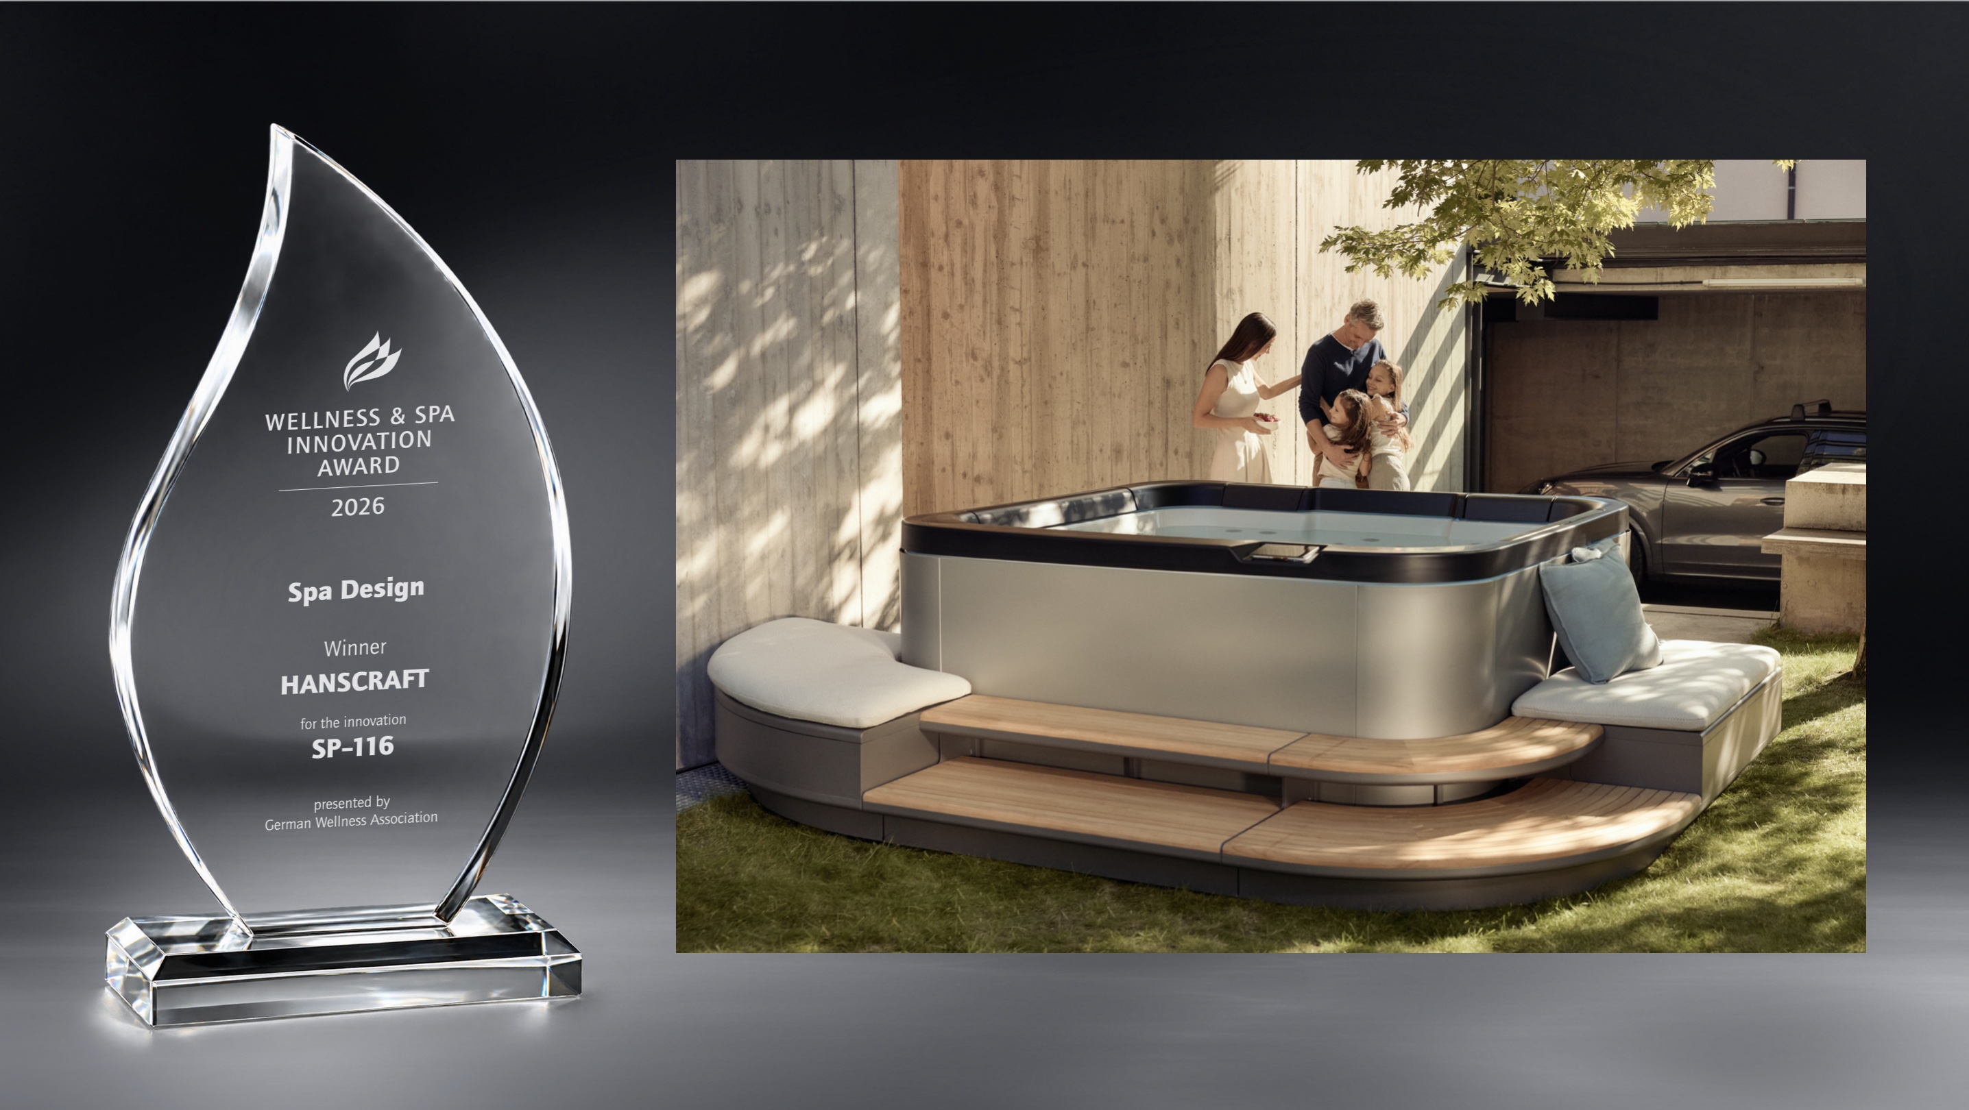

Hanscraft’s proprietary manufacturing innovation, in collaboration with Studio F. A. Porsche, has led to a design innovation that sets an unprecedented standard in the international market for outdoor spas (hot tubs). The accompanying modular elements, made of high-quality materials, expand the core product into an attractive outdoor living concept. A successful fusion of spa and wellness.

Link: https://sp116.hanscraft.com/

Wellness & Spa Innovation Award 2026 – Category Wellness Product:
SI Shape Industries – Shapes 2.0

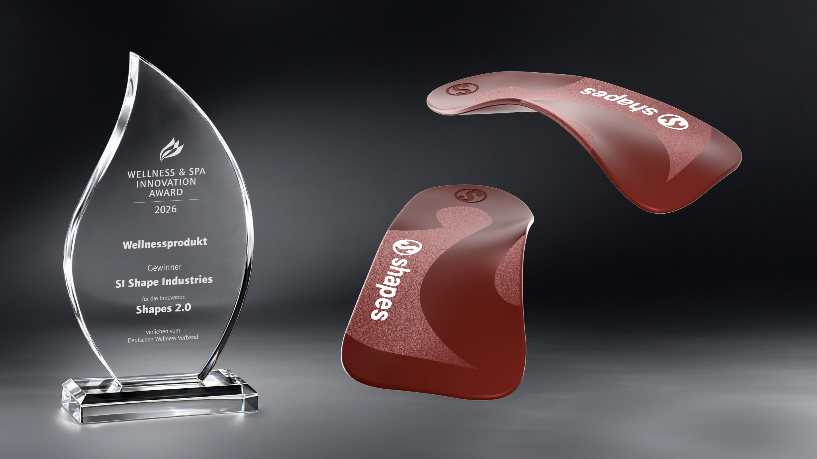

Shoe insoles with potential. Shapes differ from standard insoles, comfort soles, and orthopedic insoles in several ways. Thanks to their patented design, they are intended to activate the foot muscles and the interaction between various muscle groups, improve body balance, promote optimal posture, and even alleviate physical discomfort. A study commissioned by Shape Industries on the effects of the improved Version 2.0 has now provided initial evidence that stability and balance could improve in a specific group of competitive athletes.

Link: https://get-shapes.com

